PI49FCT32807 IBIS Model Check
IBIS Models: PI49FCT32807_H_RevA.ibs and PI49FCT32807_Q_RevA.ibs.
1. Model Type
These two ibis models are just different in packaging, their pin information are the same.
PI49FCT32807_H_RevA.ibs – 20-pin 209-mil wide QSOP (Q)
PI49FCT32807_Q_RevA.ibs– 20-pin 150-mil wide SSOP (H)

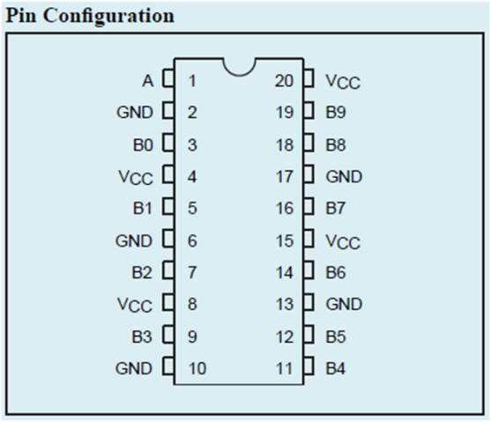
[Pin] signal_name model_name
1 A INPUT
2 GND GND
3 B0 OUTPUT
4 VCC POWER
5 B1 OUTPUT
6 GND GND
7 B2 OUTPUT
8 VCC POWER
9 B3 OUTPUT
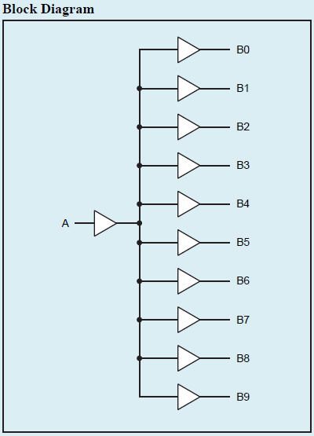
10 GND GND
11 B4 OUTPUT
12 B5 OUTPUT
13 GND GND
14 B6 OUTPUT
15 VCC POWER
16 B7 OUTPUT
17 GND GND
18 B8 OUTPUT
19 B9 OUTPUT
20 VCC POWER
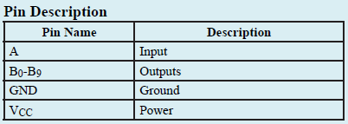

Conclusion
1. The PIN and PIN mapping information described in IBIS model is exactly correct according to the datasheet.

2. Internal Series Resistor based on IBIS Model:
1) PullDown: V = 0.09917V, I = 0.00402A, so Rs = 23.612Ω
V = -0.09915V, I = -0.00404A, so Rs = 24.542Ω
2) PullUp: V = 0. 09918V, I = 0. 00391A, so Rs = 25.366Ω
V = -0. 09913V, I = -0. 00384A, so Rs = 25.815Ω

Conclusion:
The values of Internal Series Resistor based on IBIS model are correct according to the datasheet.
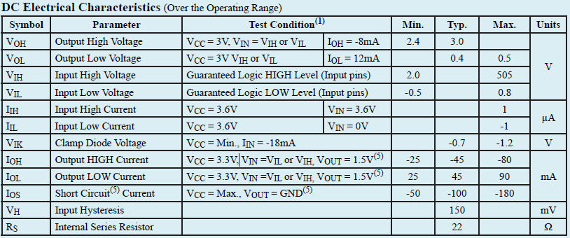

3. Analog Switch simulation result with following circuit diagram:
PI49FCT32807
OUT1

SCL_C
SDA_C
25Ω / 33Ω

SCL_C
SDA_C
50Ω

SCL_C
SDA_C
IN

SCL_C
SDA_C
C

SCL_C
SDA_C
OUT

SCL_C
SDA_C
IN

SCL_C
SDA_C
OUT0

SCL_C
SDA_C
Trace=2inch

SCL_C
SDA_C
Input signal frequency is 250MHz:
a. Add 25Ω resistor, 2inch trace and 5pF pull-down capacitance to the output.
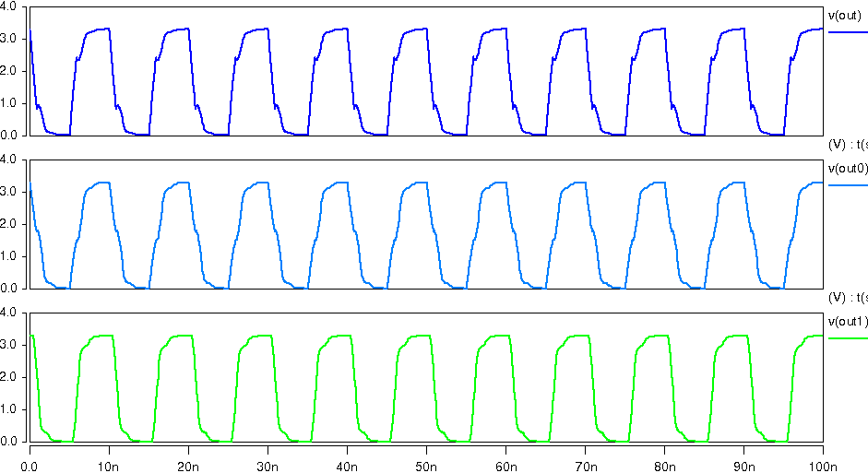

a. Add 33Ω resistor, 2inch trace and 5pF pull-down capacitance to the output.
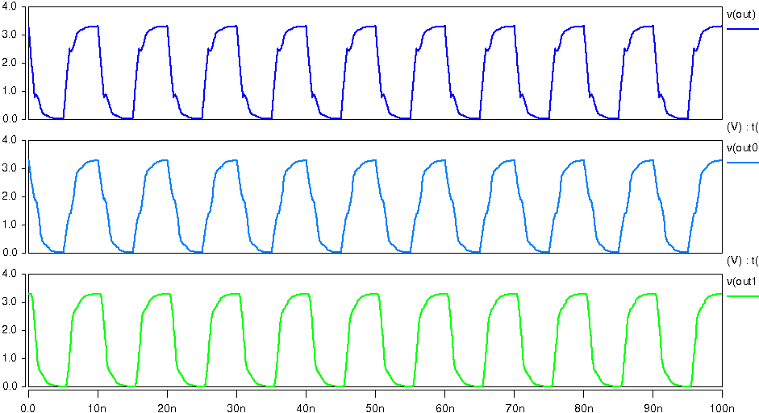

4. IBIS Data Graph of the IBIS models
(1) Model INPUT:
a. POWER Clamp
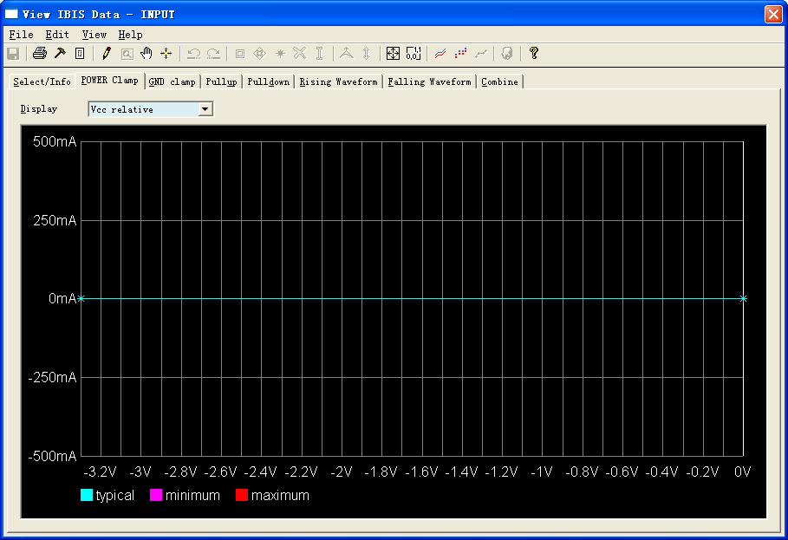
b. GND Clamp
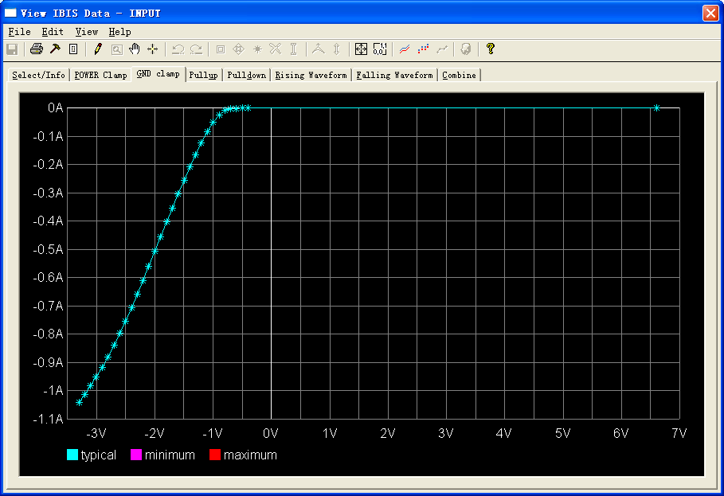

(2) Model OUTPUT:
a. Pullup
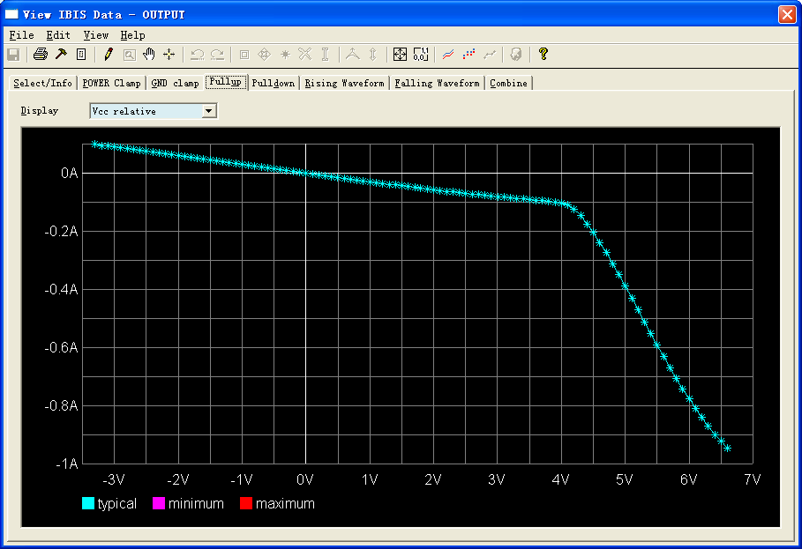
b. Pulldown
